Project Specification Document

--------------------------------------------------------------------------------------------------- **Document Version 1.0** **Latest updated: 27-02–2022**

**Author: Suraj Singh**

**Backend Admin for Learner’s Academy.**

**Content**

**1. About this Document------------------------------------------------------------1**

**1.1 How this Document is organized-------------------------------------1**

**1.2 Contact Information----------------------------------------------------2**

**2. Introduction------------------------------------------------------------------------3**

**2.1 Objectives------------------------------------------------------------------3**

**3. Flow chart--------------------------------------------------------------------------4**

**3.1 Flow chart diagram--------------------------------------------------------4**

**4. Solution Overview-----------------------------------------------------------------5**

**UI for Admin------------------------------------------------------------------5 to 20**

**UI for User--------------------------------------------------------------------21 to29**

**5. Database Description---------------------------------------------------------29 to 39**

**6. GitHub link-------------------------------------------------------------------------40**

1. **About this Document**

This functional and integration (FIS) document will enable you to understand the proposed solution of Flyaway.com

The content of the document will have a solution and its configuration details as it will be available for our client.

**1.1 How this Document is organized**

This document is organized into following chapters:

**Chapter 1 -** "Introduction" provides solution scope to be delivered to our client.

**Chapter 2 -** "Flow chart" provides how the user is interacting with the application.

**Chapter 3 -** "Solution Overview" provides information on Company Lockers Pvt. Ltd., Components and Interfaces in system.

**Chapter 4 -** “Open Items” provide information about the software enhancement still to be done.

**Chapter 5- “GitHub link”** provides the information where the project is located.

**1.2 Contact Information**

Flyaway welcomes your comments and suggestions on the quality and usefulness of this document. For any questions, comments, or suggestions on the documentation, you can contact us at the following address:

|  |
| --- |
|  |

**2. Introduction**

This document describes the implementation of *Learner’s Academy* and how its users can interact with the application.

*Learner’s Academy is a school that has an online management system. The system keeps track of its classes, subjects, students, and teachers. It has a back-office application with a single administrator login.*

**2.1    Objectives**

The objective of this document is to describe how the solution of *Learner’s Academy* will integrate with User.

This document also provides information on end-to-end workflow flow so that business users and mainly admin can understand the features and functionalities of the *backend administrative portal for the Learner’s Academy*.

The workflow mainly involves the following important aspects,

1. Set up a master list of all the subjects for all the classes
2. Set up a master list of all the teachers
3. Set up a master list of all the classes
4. Assign classes for subjects from the master list
5. Assign teachers to a class for a subject (A teacher can be assigned to different classes for different subjects)
6. Get a master list of students (Each student must be assigned to a single class)
7. There will be an option to view a Class Report which will show all the information about the class, such as the list of students, subjects, and teachers.

**3. Flow chart**

**3.1** The objective of this session to show how the user interacts with the flow of the *Learner’s Academy****.***

Home Page View

ForgotPassword

AdminLogin

TeacherLogin

StudentLogin

All Admin Operation Like Set-up of Classes, Teachers and Students

View Your Schedule of Sessions

View Your Schedule of Classes

Assign operation for Classes and Teachers For Students and getting assigned students master List

**5 Solution Overview**

**Platform requirement**

The platform used for this project is the STS3 (Spring Tool Suit 3), Tomcat, MySQL Workbench.

**5.1. UI for User:**

**Below is the welcome page of the application**

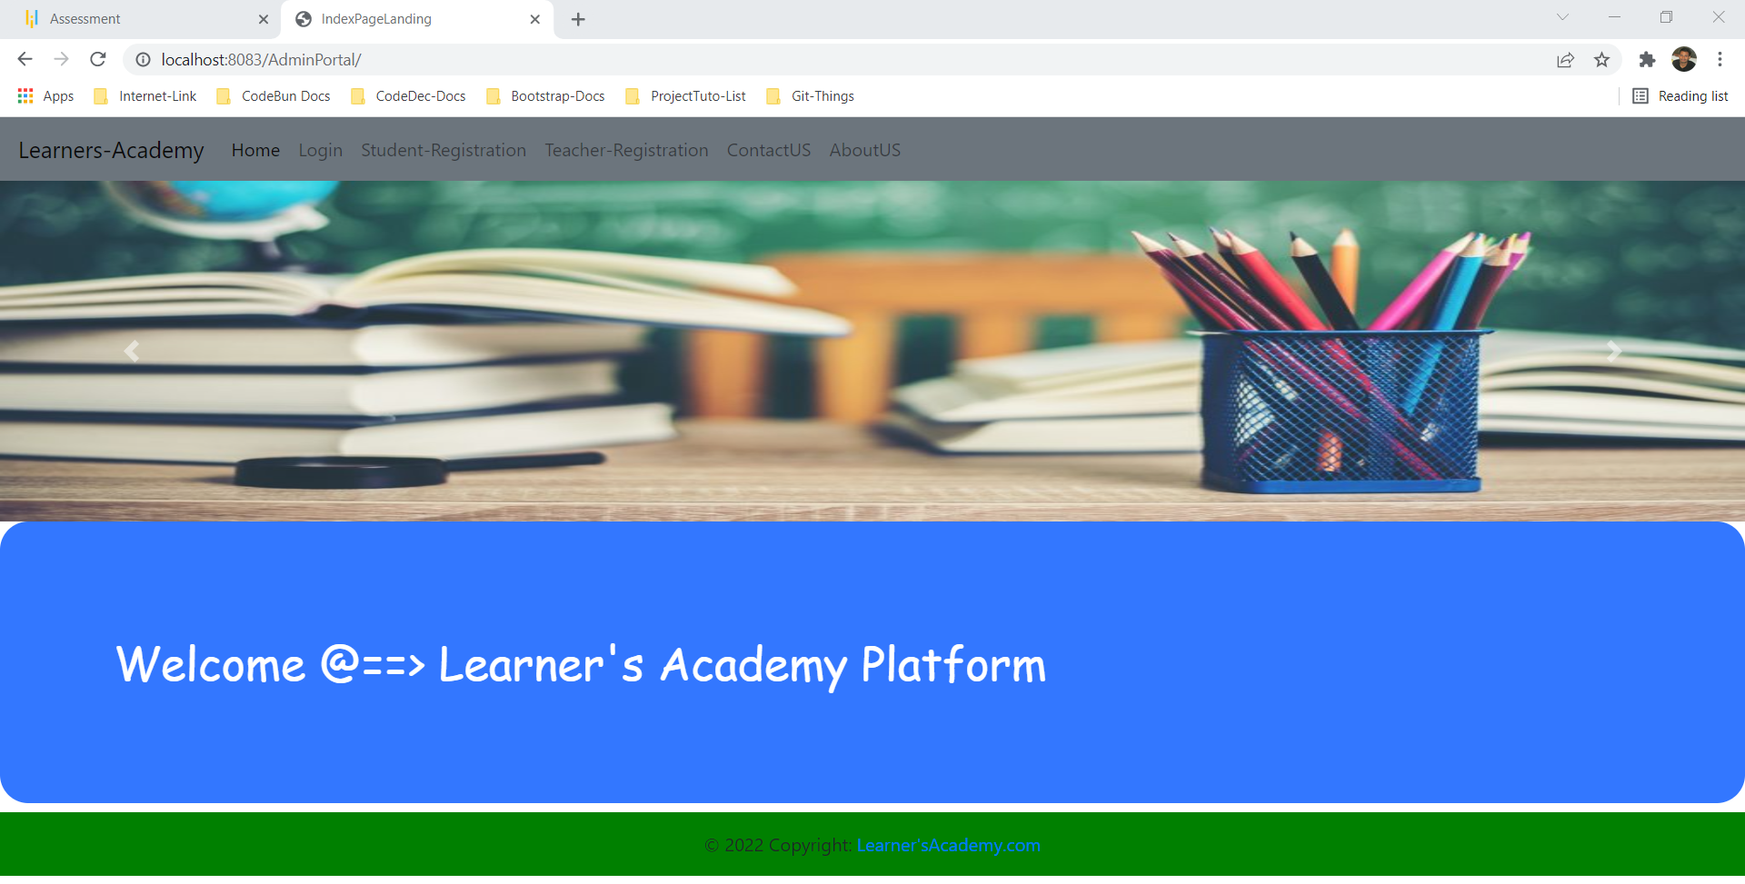

**Step 1 –**

User is allowed toregister as a student and as a teacher. After that they can login as teacher or as student and they can view their schedule of classes. But it is mainly admin-based application so Admin login is also there and maximum module we are going to perform at the admin level only. So, first we will understand the working of admin module.

This page is especially created so that the admin can be able to maintain the master lists related to Application without actually connecting to the backend.

In order to access the admin panel, the user must select Admin as on the button shown below. This page is for admin to login into the login panel.

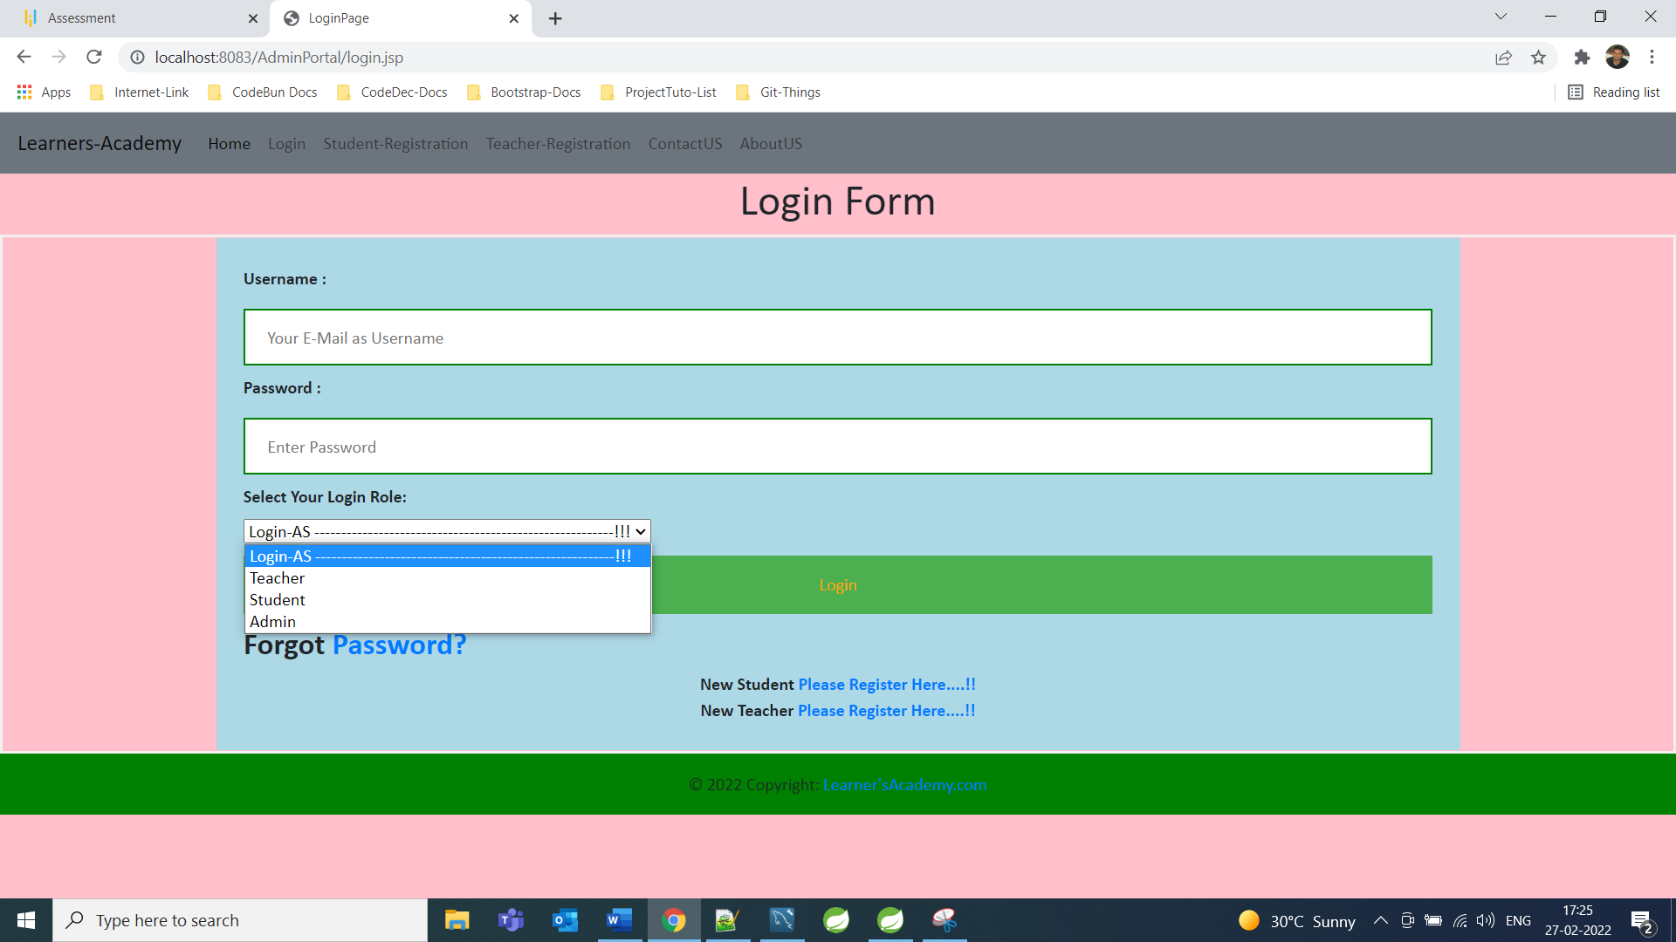

**Step 2 -**

The admin is allowed to perform following operations, the credentials for admin is

Username [-admin370@gmail.com](mailto:-admin370@gmail.com)

Password -admin123

Login AS -Admin

The admin can perform operations once he is logged in.

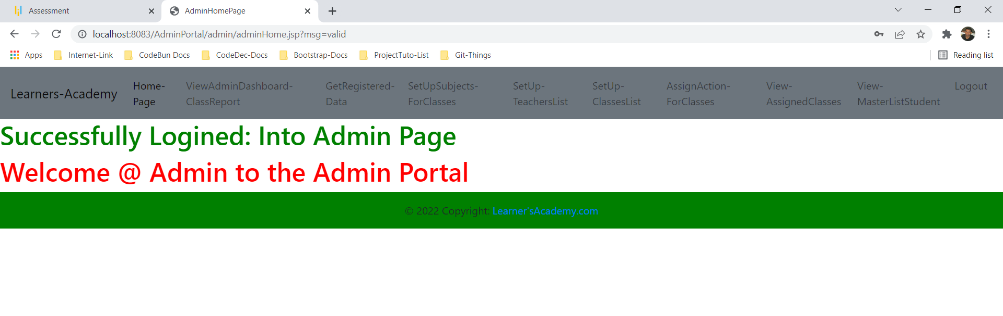

Very first admin can view Dashboard where admin can show complete class report.

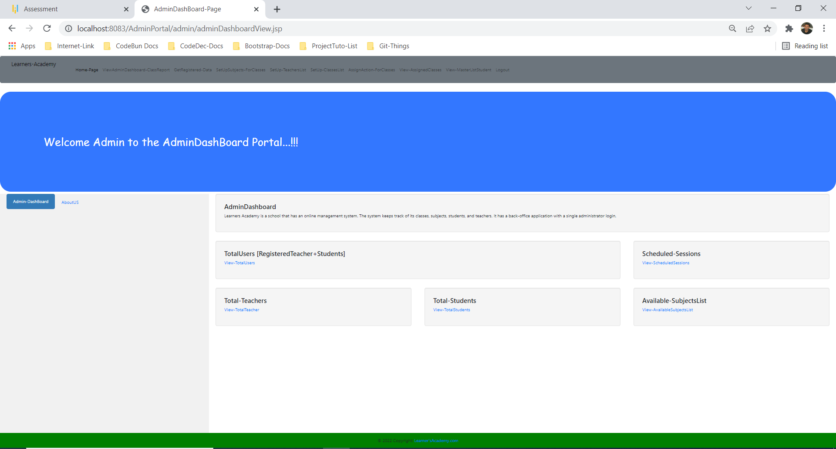

**View Total Registered User (Total Student and Teacher)**

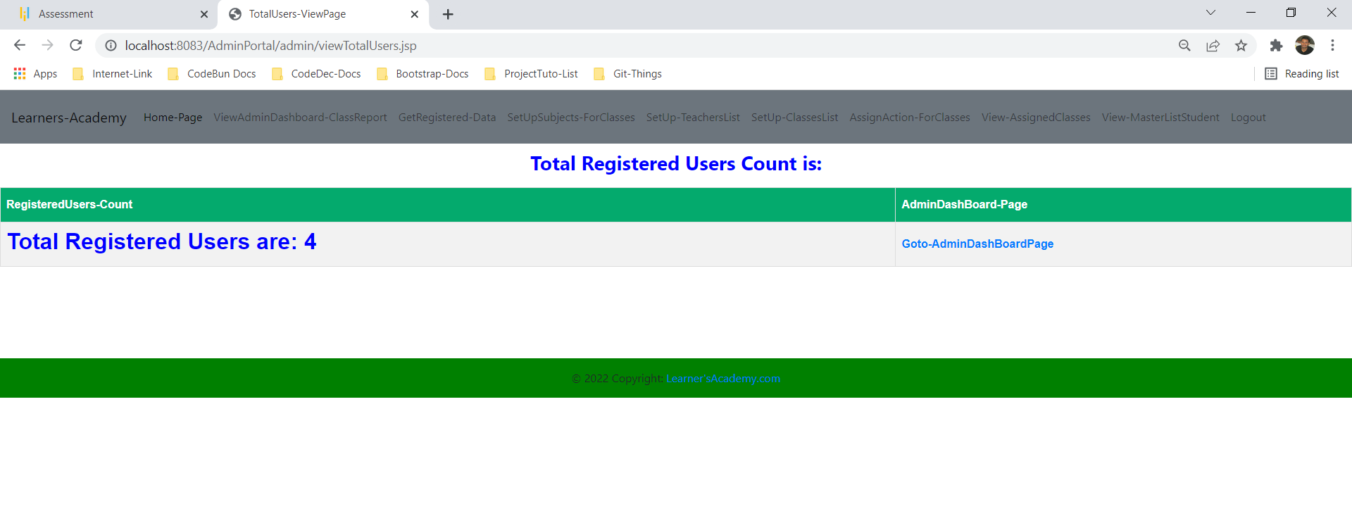

**View Scheduled Class**

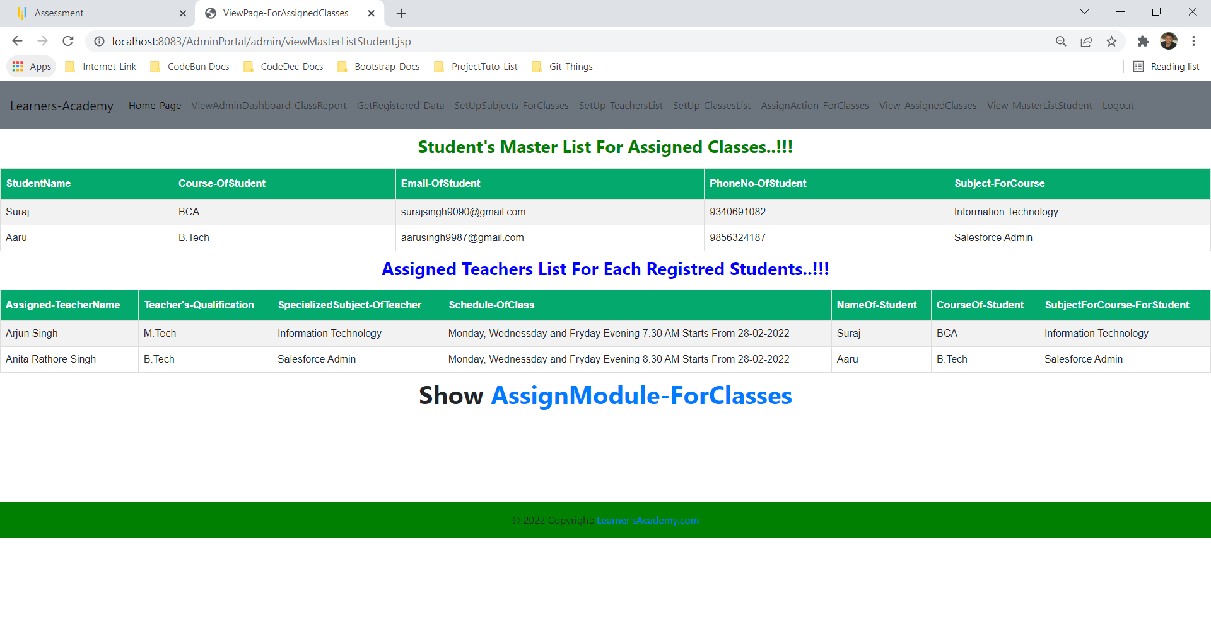

**Total teacher count view**

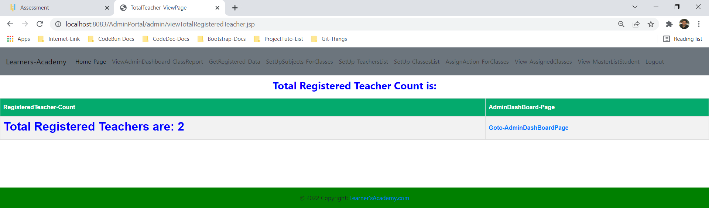

**Total Student Count View**

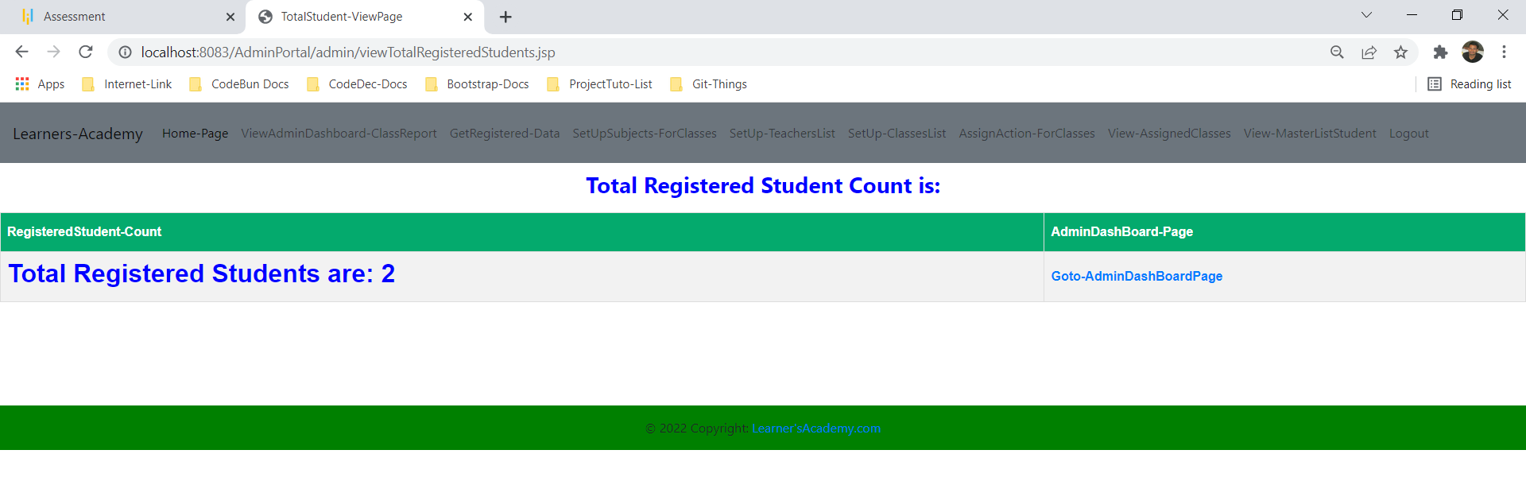

**Available Subjects list View**

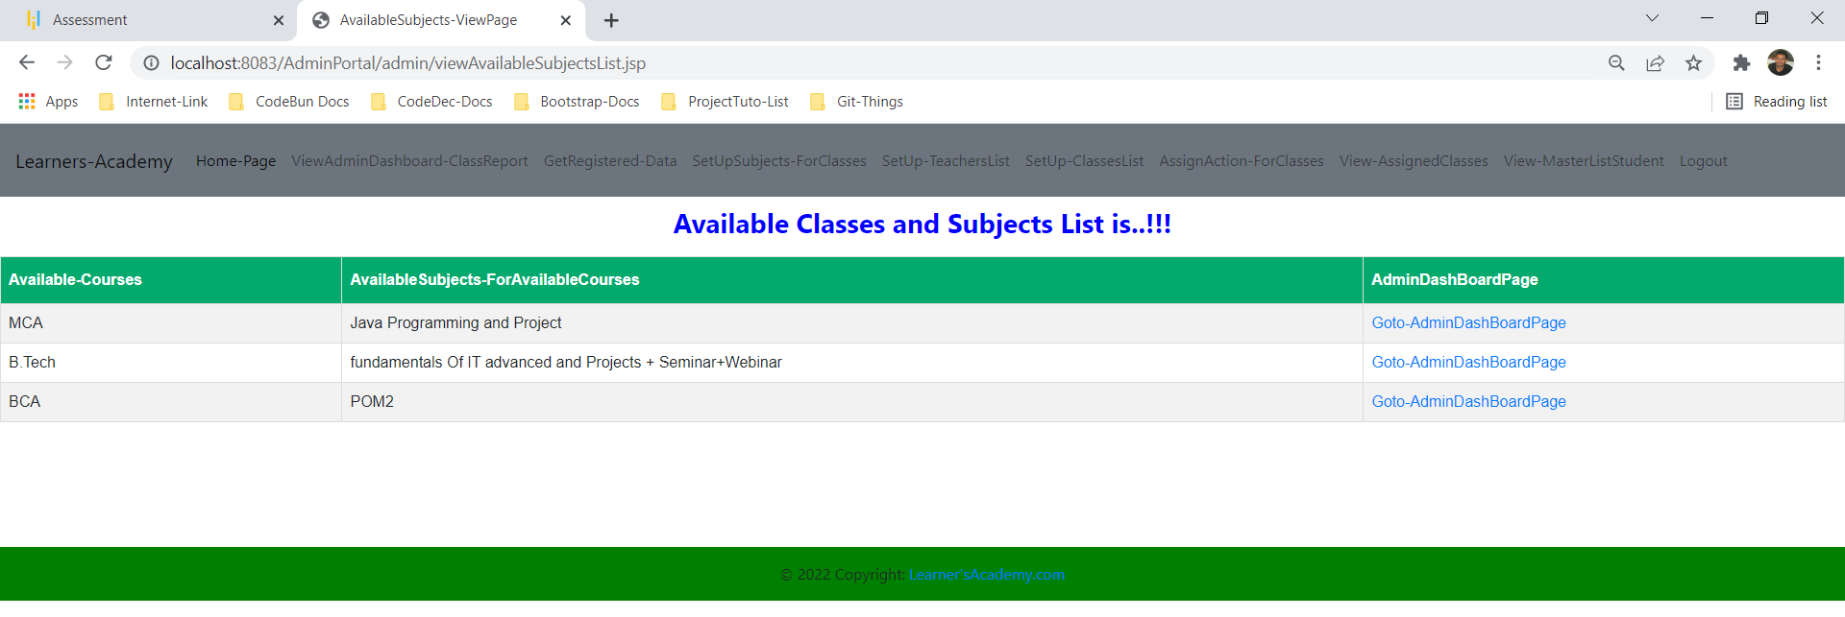

**==========================================================**

**Step 2 –**

Admin can retrieve all the registered data for assigning classes for student as well as for teacher.

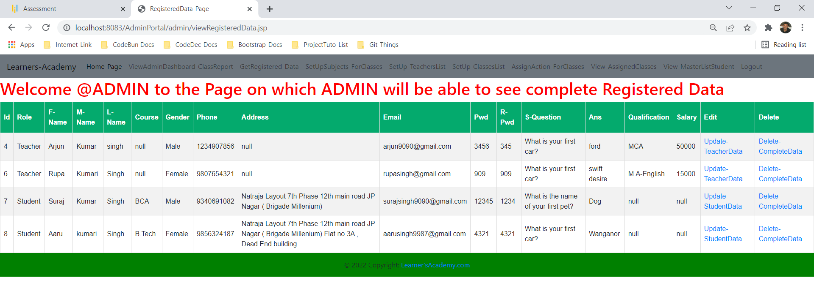

Form this page admin can update or delete operation for registered data as per requirement.

**==========================================================**  
**Step 3-**

Admin can add Subject List for all the class and can get master list of subjects for assigning the classes to the teacher and students.

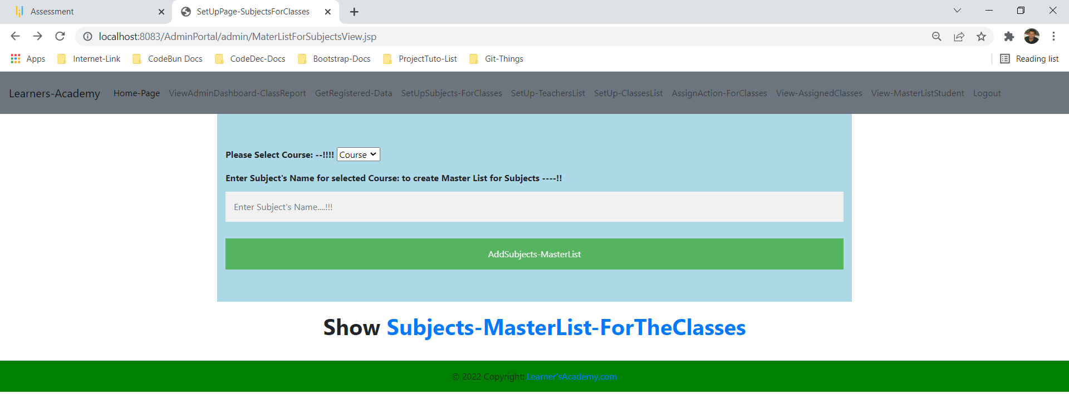

**View Master list of Subjects**

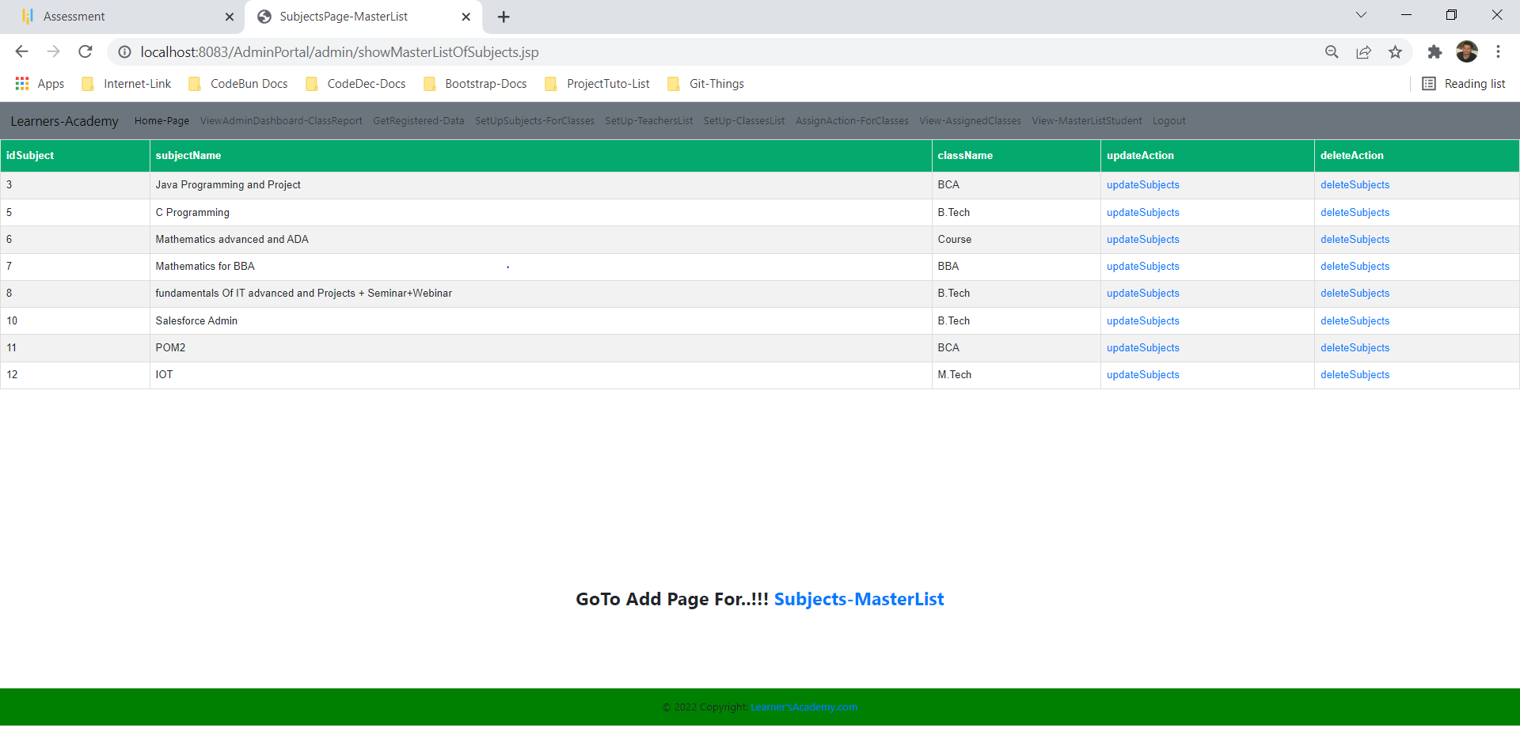

From here also admin can update or delete subjects list.

**Step 4-**

Admin can setup Teacher List according to teachers’ qualification and specialization so that later admin can assign teachers to the students and to the class.

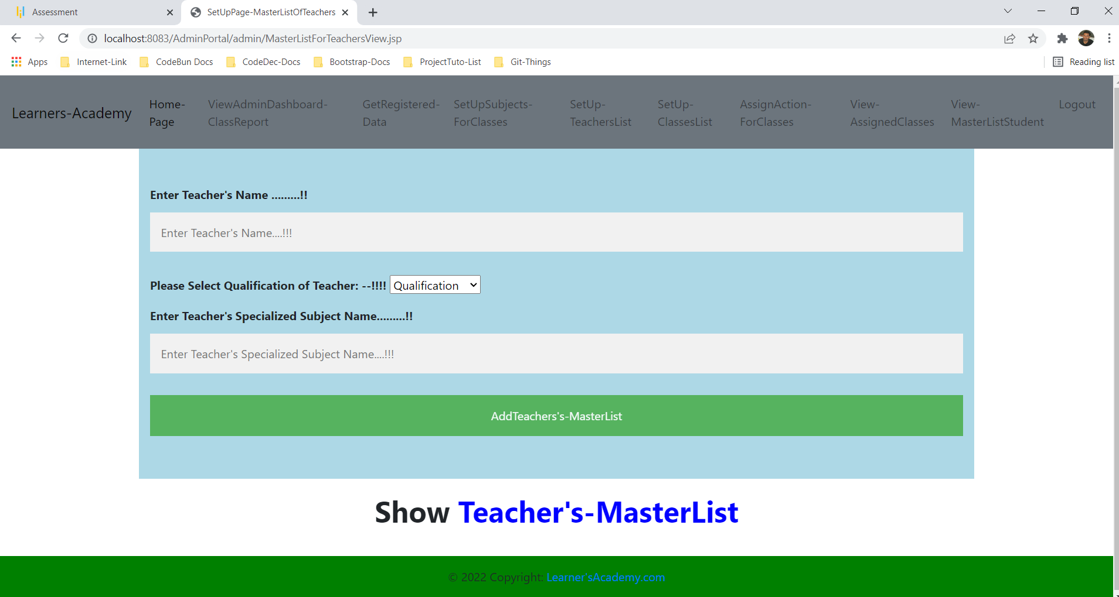

**View Teacher’s Master List after setup of teacher’s master list**

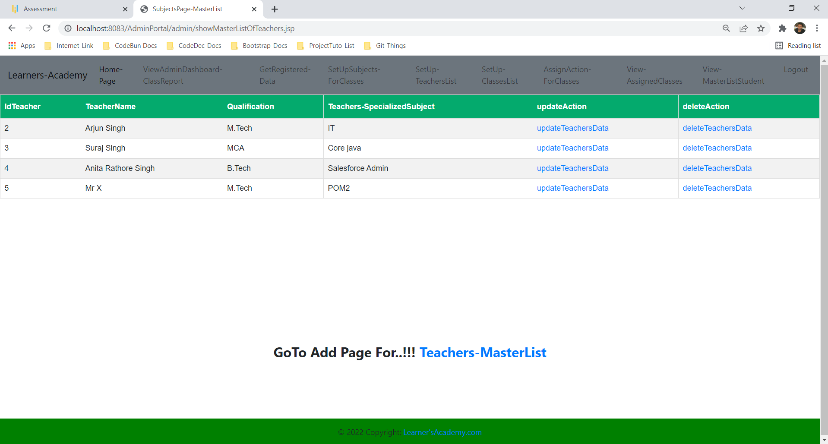

**Step 5-**

Admin can setup Class List according to students’ course so that later admin can assign teachers to the students and to the class.

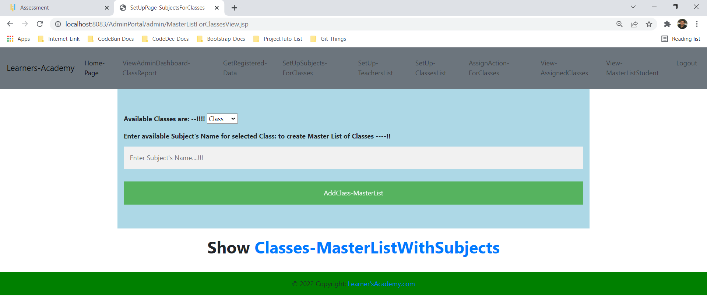

**View class’s Master List**

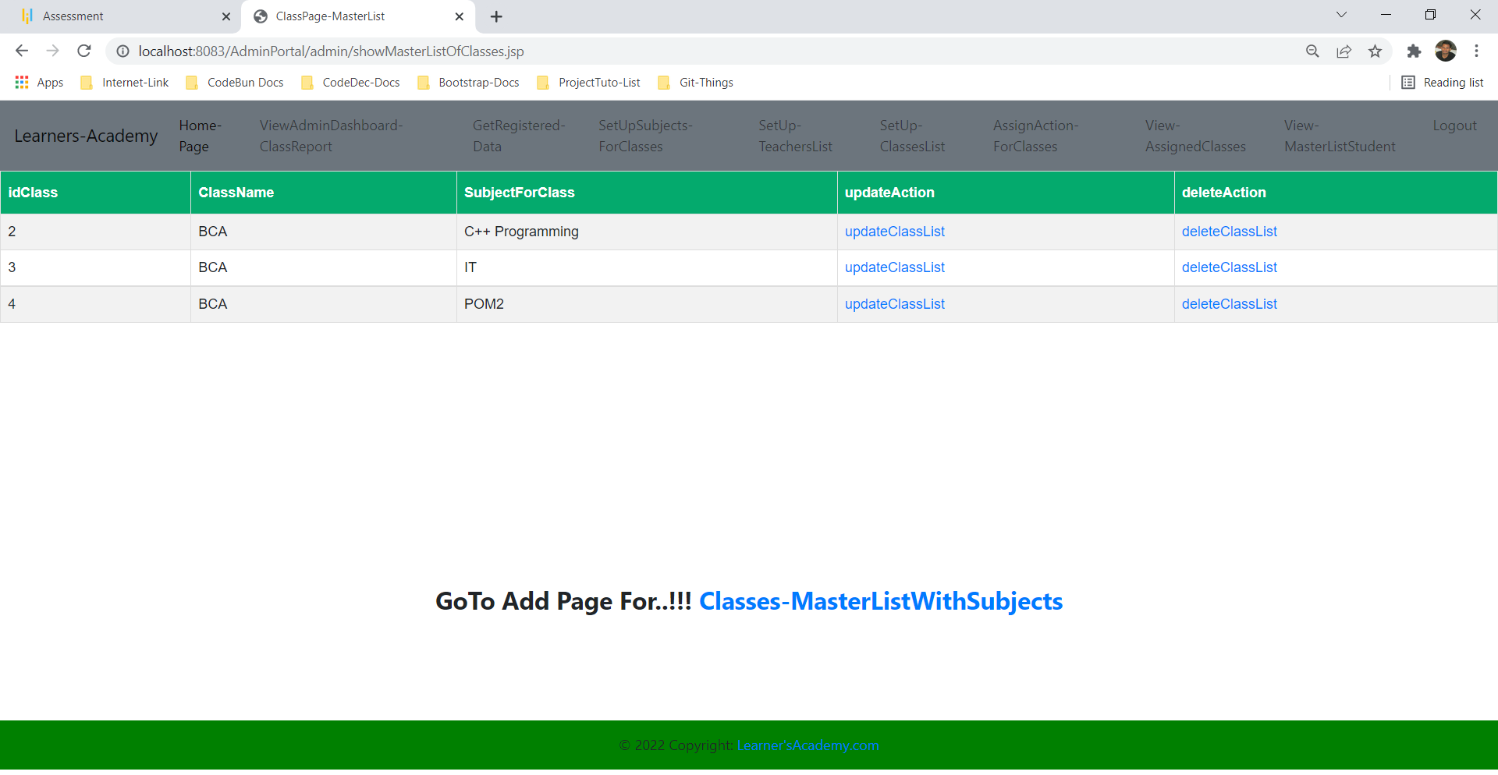

**According to need classes can be updated and deleted.**

**Step 6-**

Now admin can perform Assign Class action module based on master list of class , student and teacher.

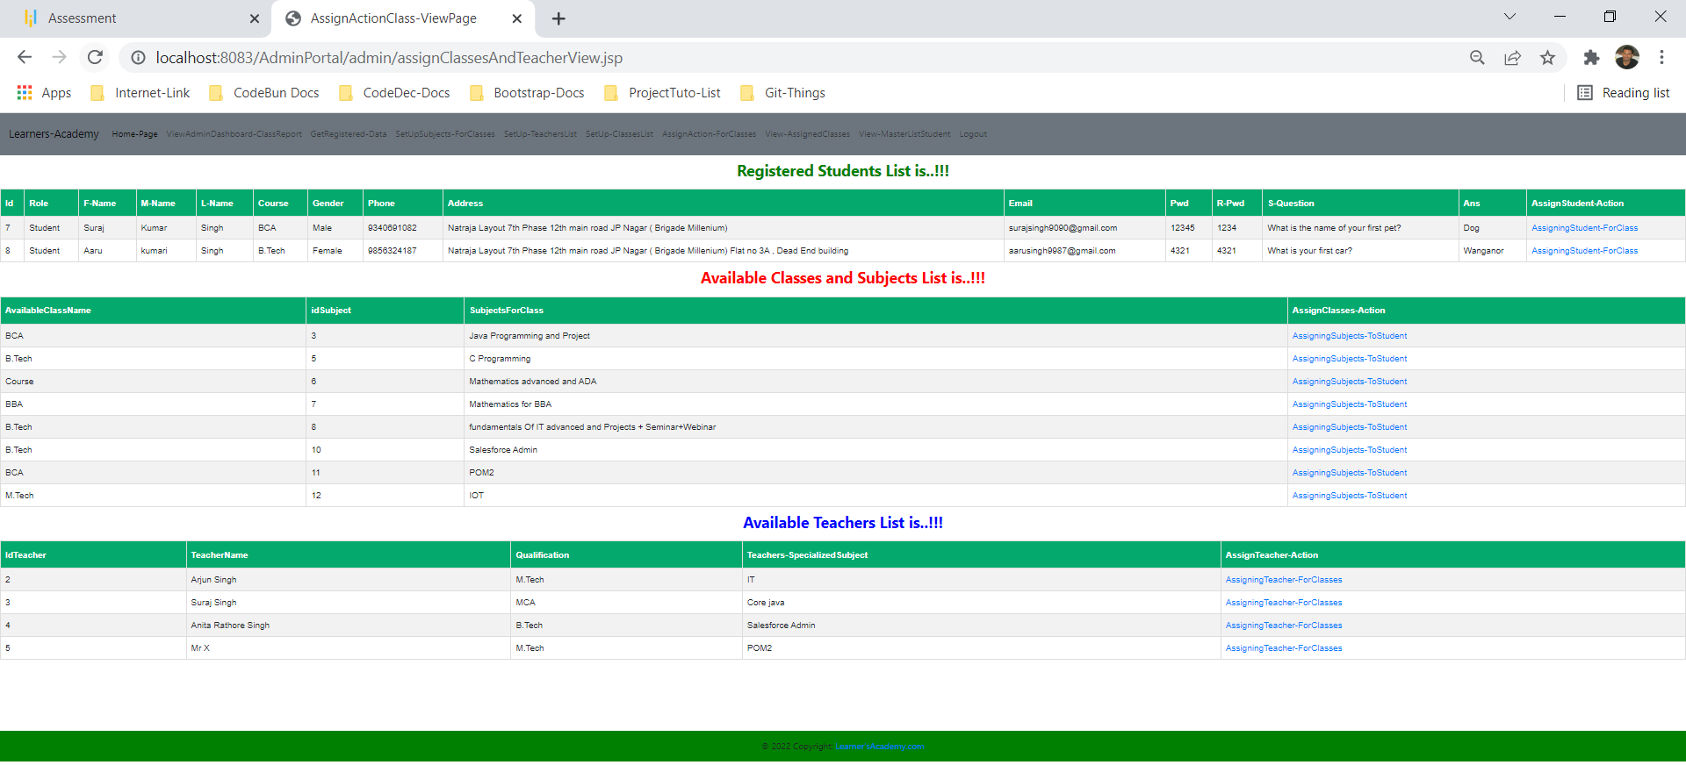

Here admin by clicking on [AssigningStudent-ForClass](http://localhost:8083/AdminPortal/admin/assignClassesActionView.jsp?idStudent=7) can assign class to students

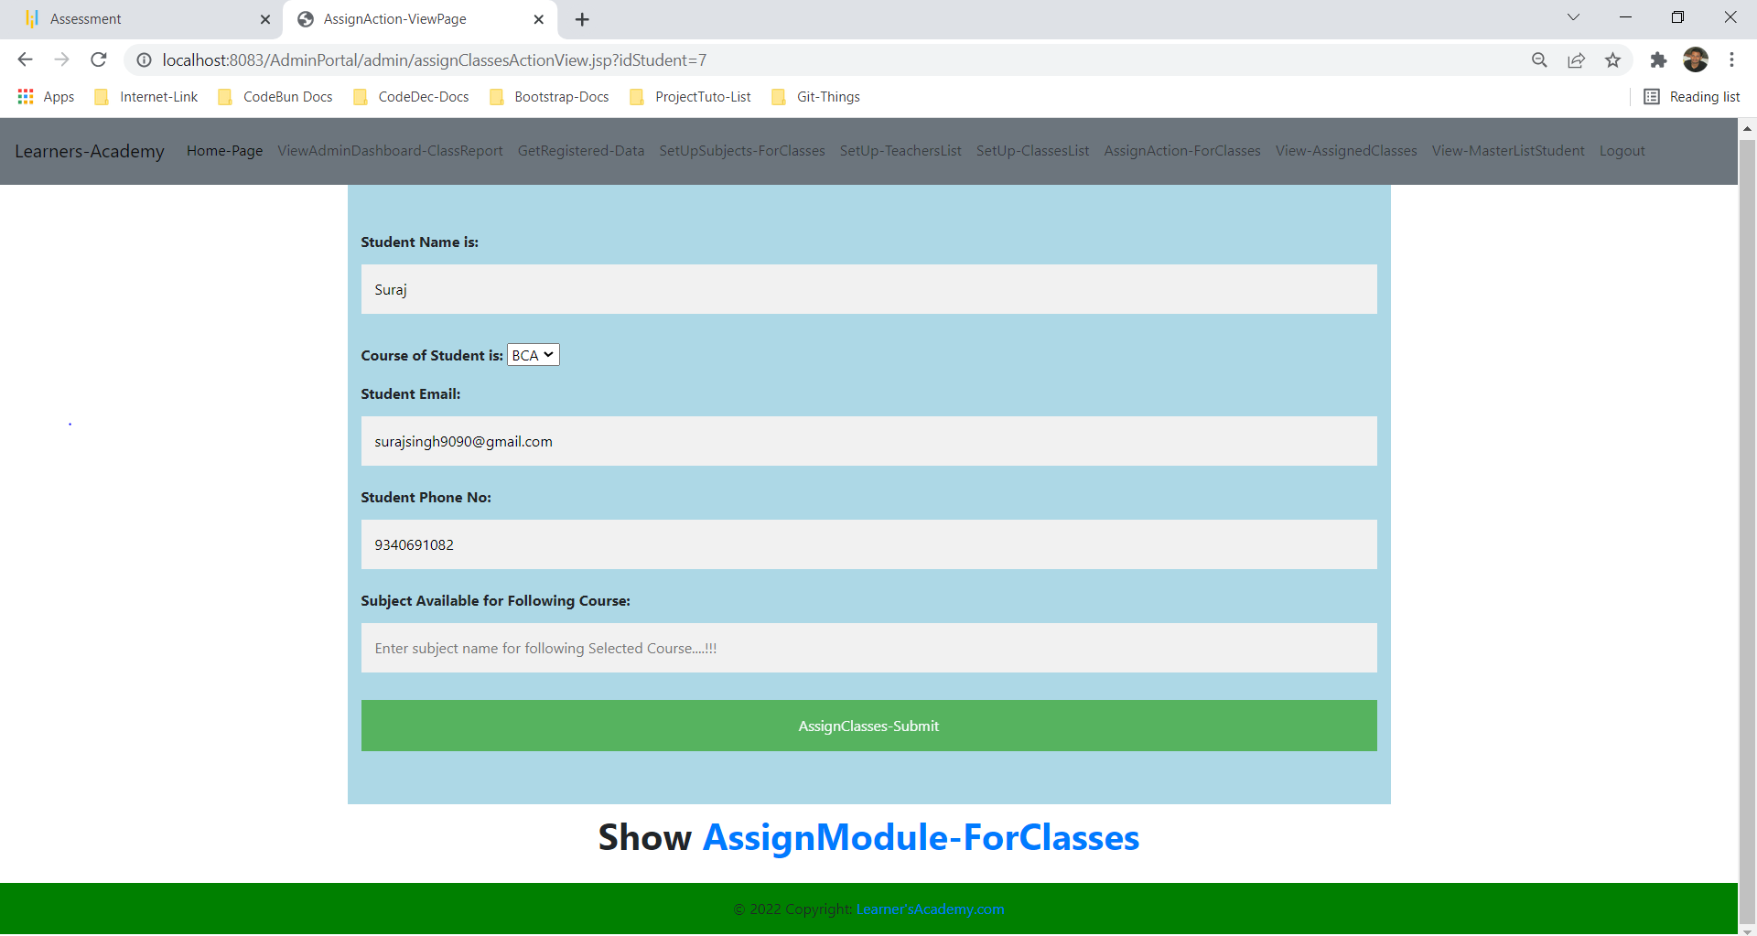

Here admin by clicking on [AssigningSubjects-ToStudent](http://localhost:8083/AdminPortal/admin/assignClassesActionView.jsp?idSubject=3) can assign subjects to students

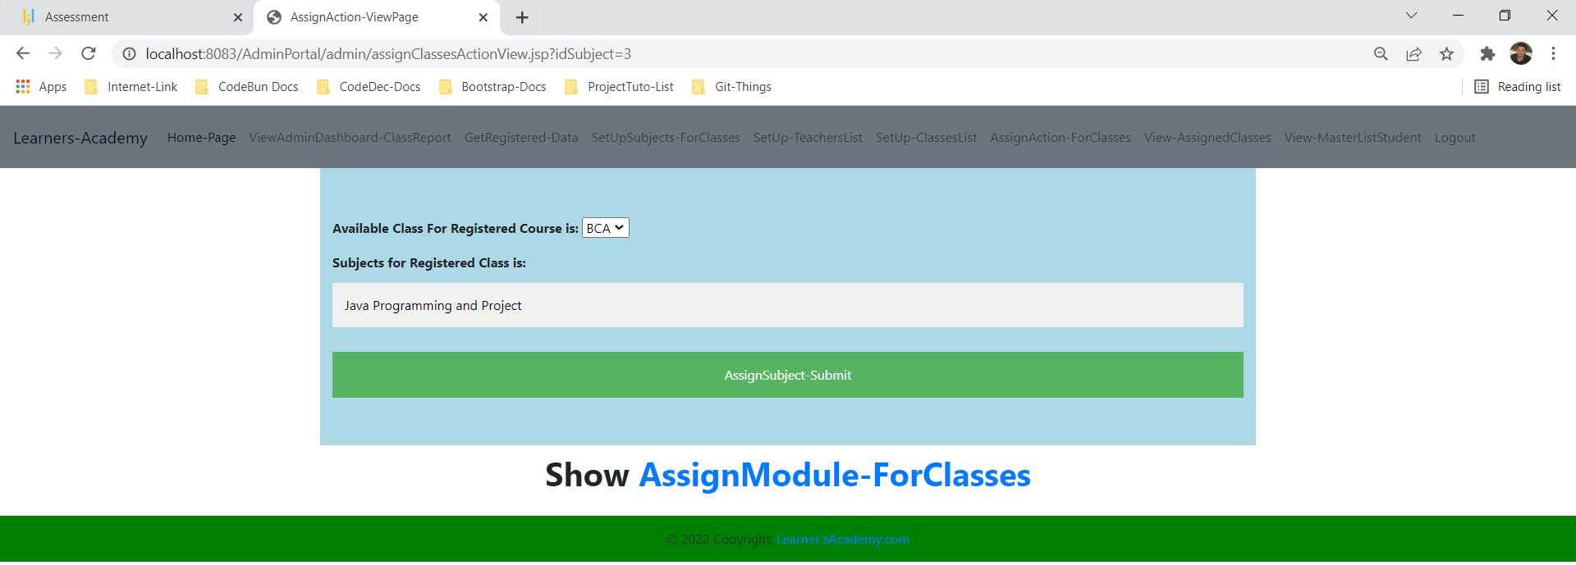

Here admin by clicking on [AssigningTeacher-ForClasses](http://localhost:8083/AdminPortal/admin/assignClassesActionView.jsp?idTeacher=2) can assign teacher to students.

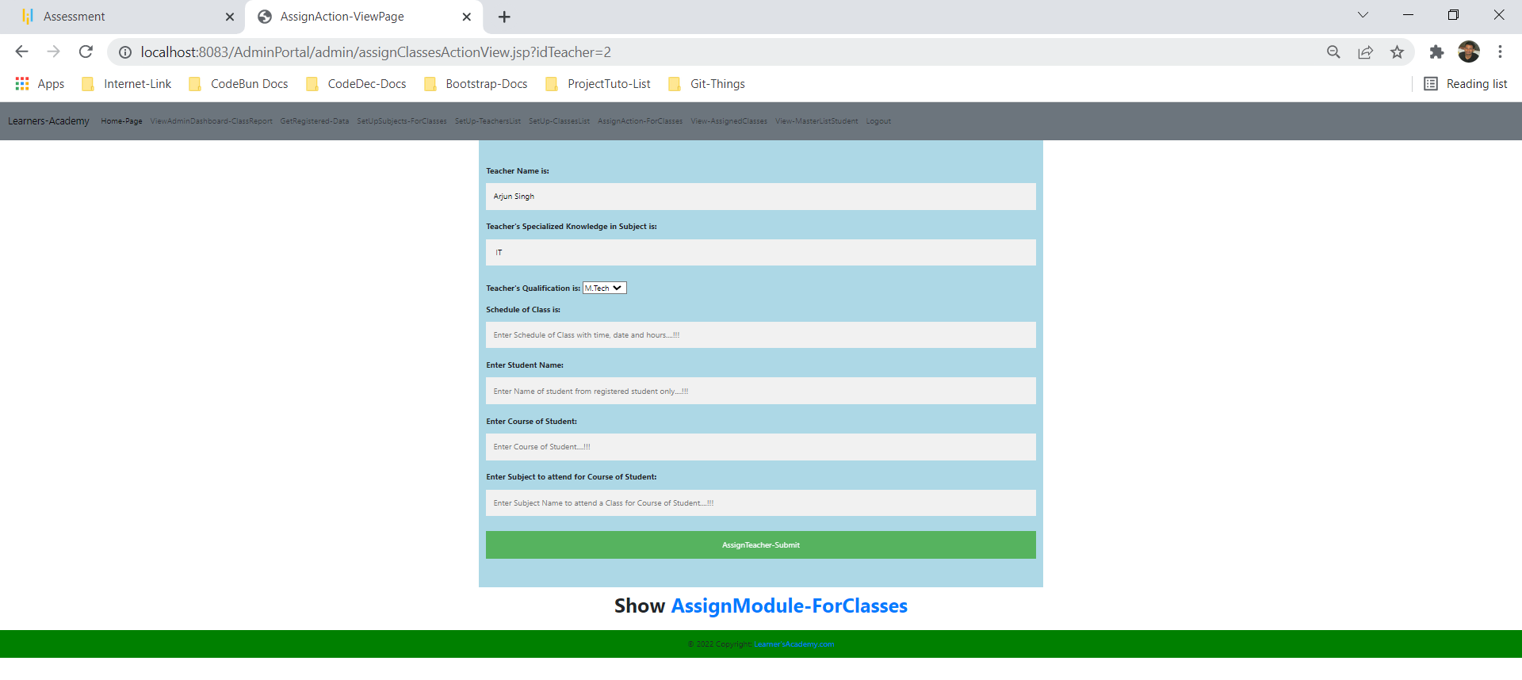

**Step 7-**

Now admin can view assigned classes

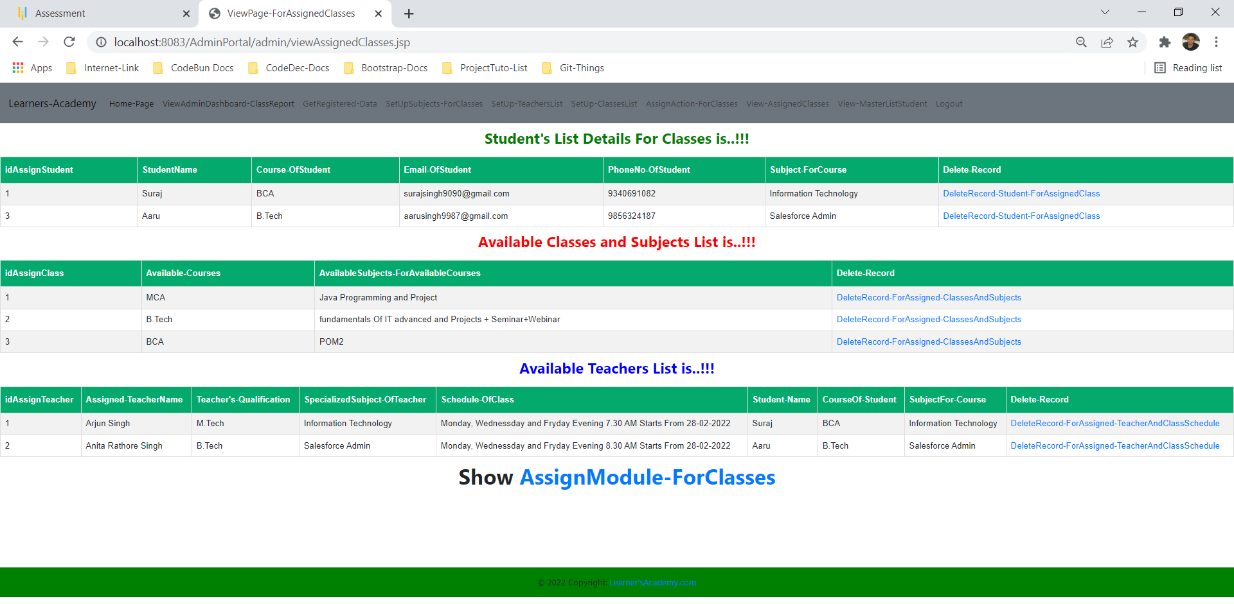

From this page admin can delete assigned classes.

**Step 8-**

Admin can access Student’s Master List who has been assigned class

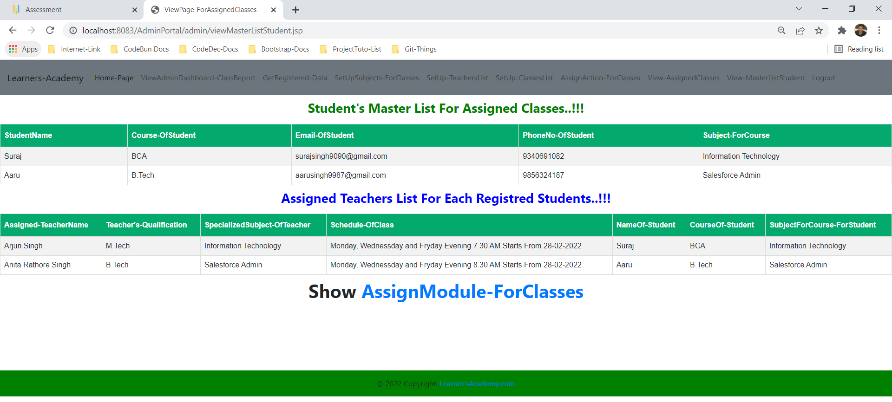

**Step 8-**

Admin can perform logout Operation.

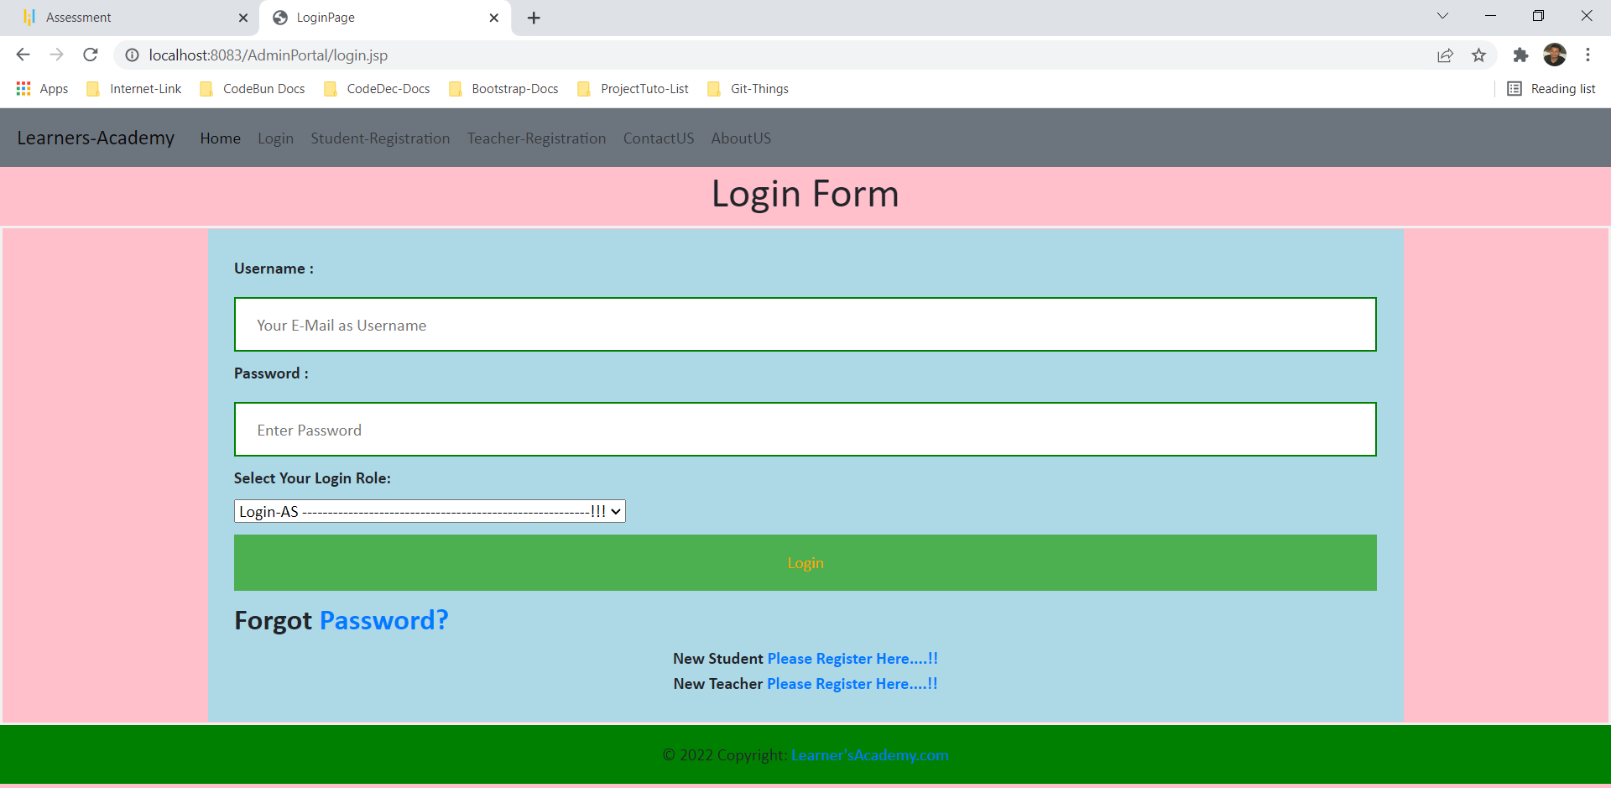

**Step 9-**

To Perform Login Operation for Teachers and Students first they need to registered.

**Student-Registered View**

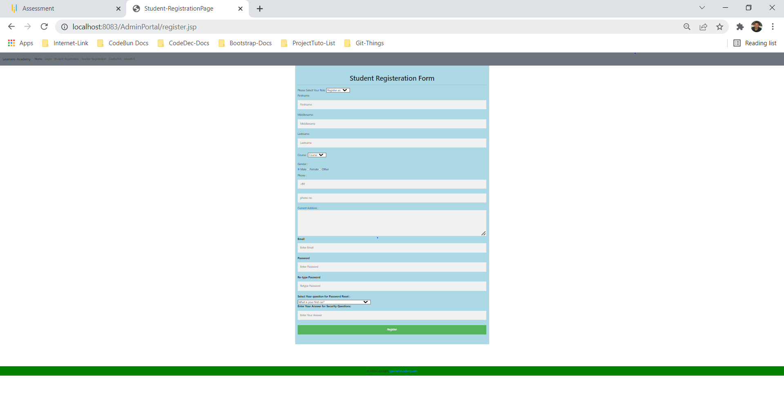

**Teacher-Registered View**

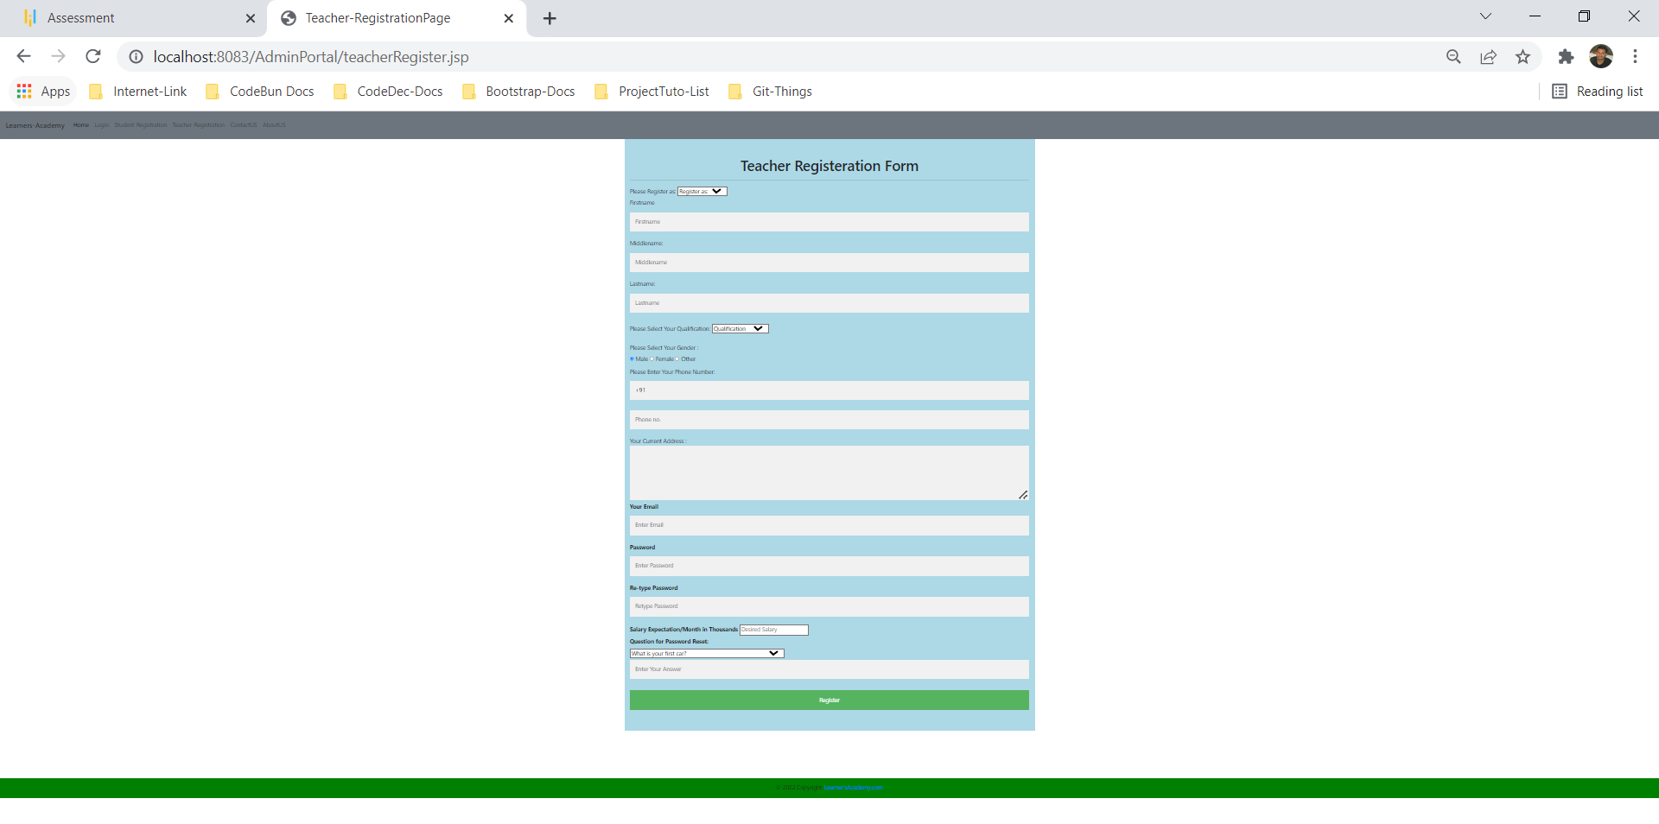

**Step 10-**

Student Login View Operation.

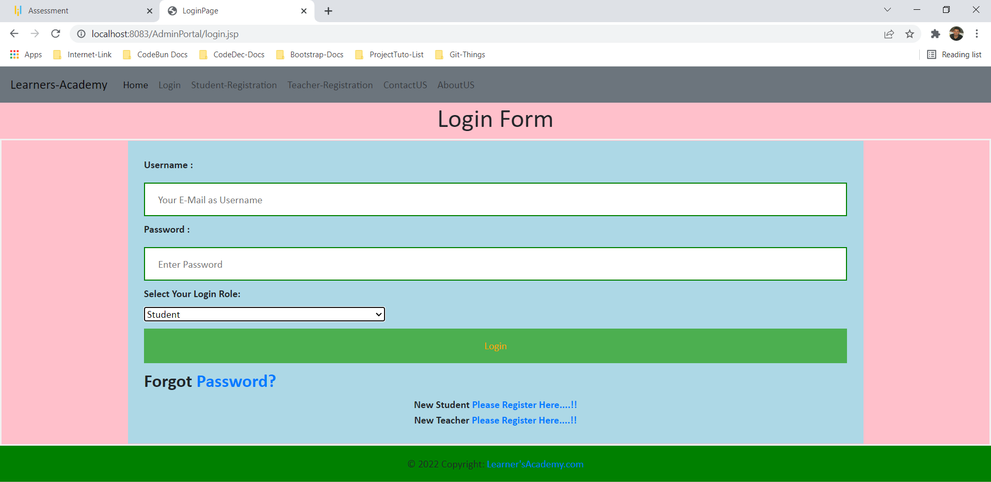

After Login Student Can View their scheduled class.

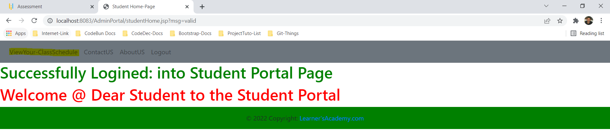

To show your scheduled class you need to enter your registered first name and your course here then student will be able to see their scheduled class.

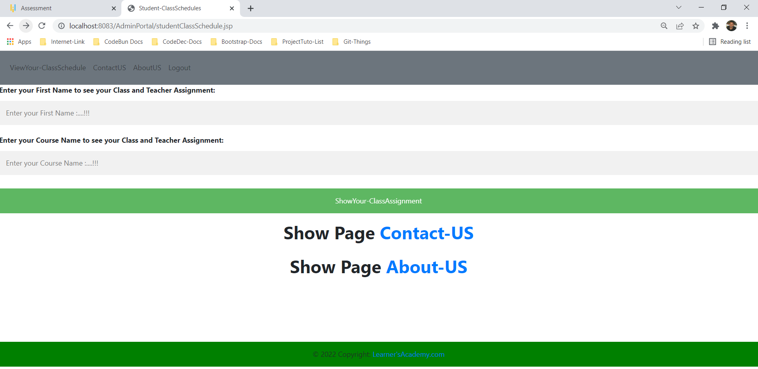

Now submit this Form to show your Scheduled Class

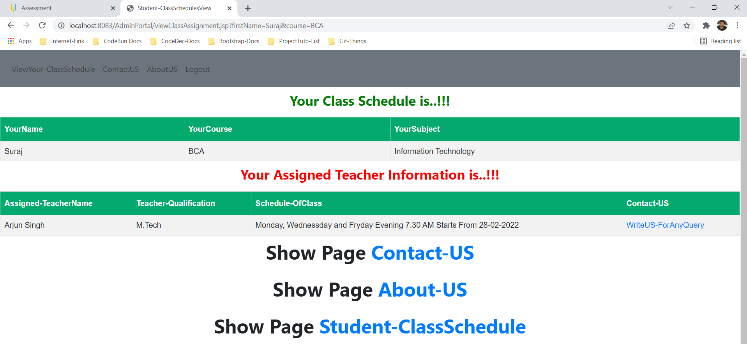

For any problem student can write query to us by clicking on [WriteUS-ForAnyQuery](http://localhost:8083/AdminPortal/contactUS.jsp)

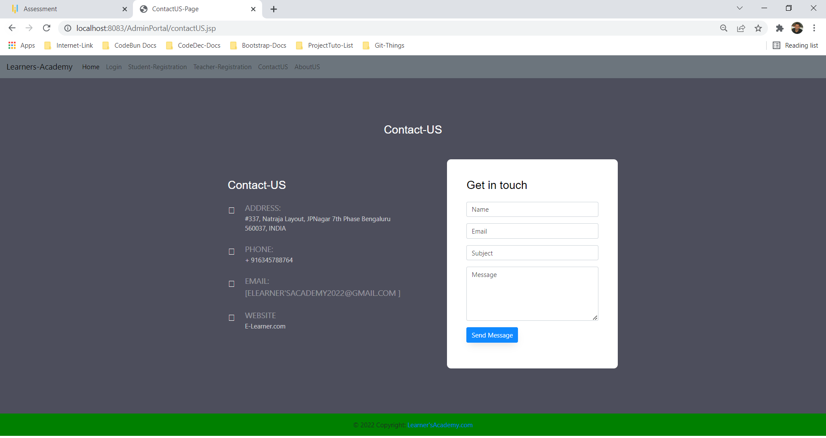

**Step 11-**

Teacher Login View Operation.

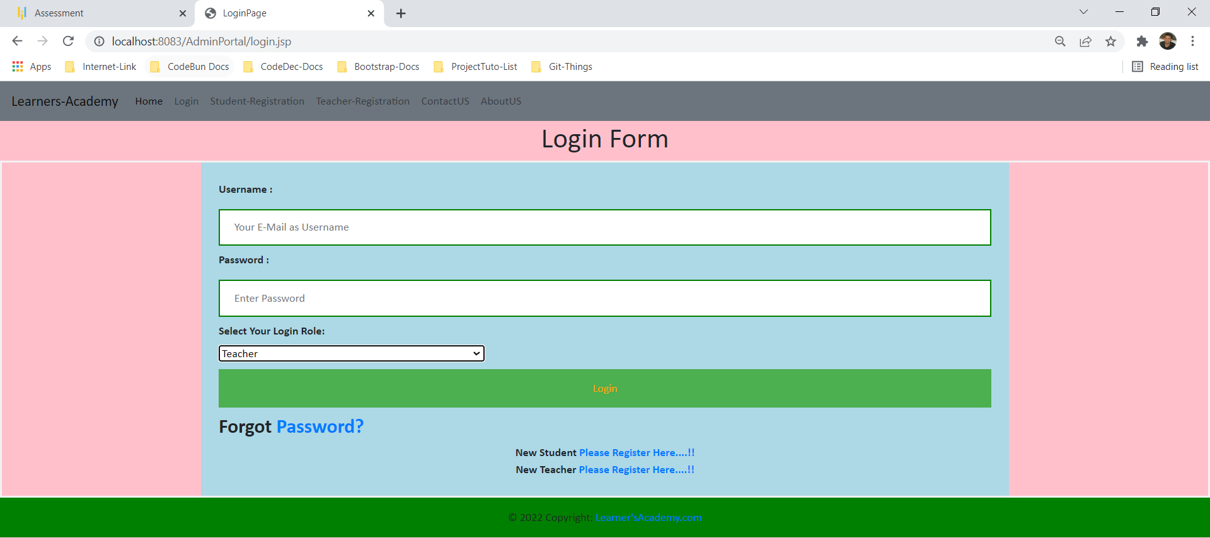

After Login Teacher Can View their scheduled sessions.

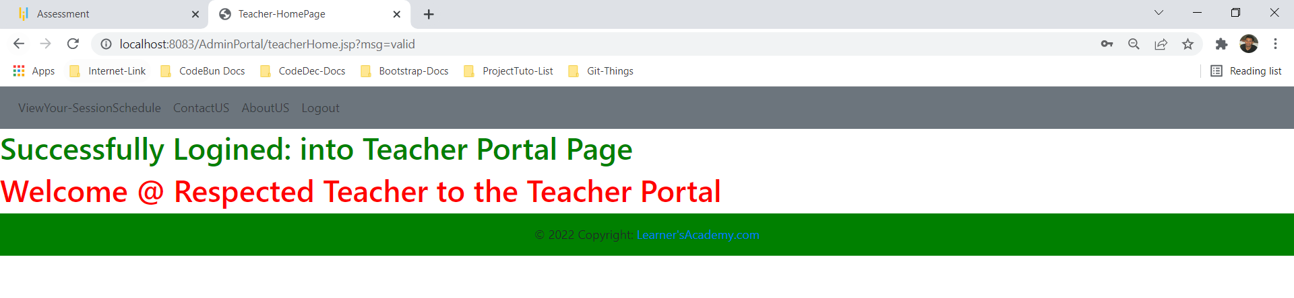

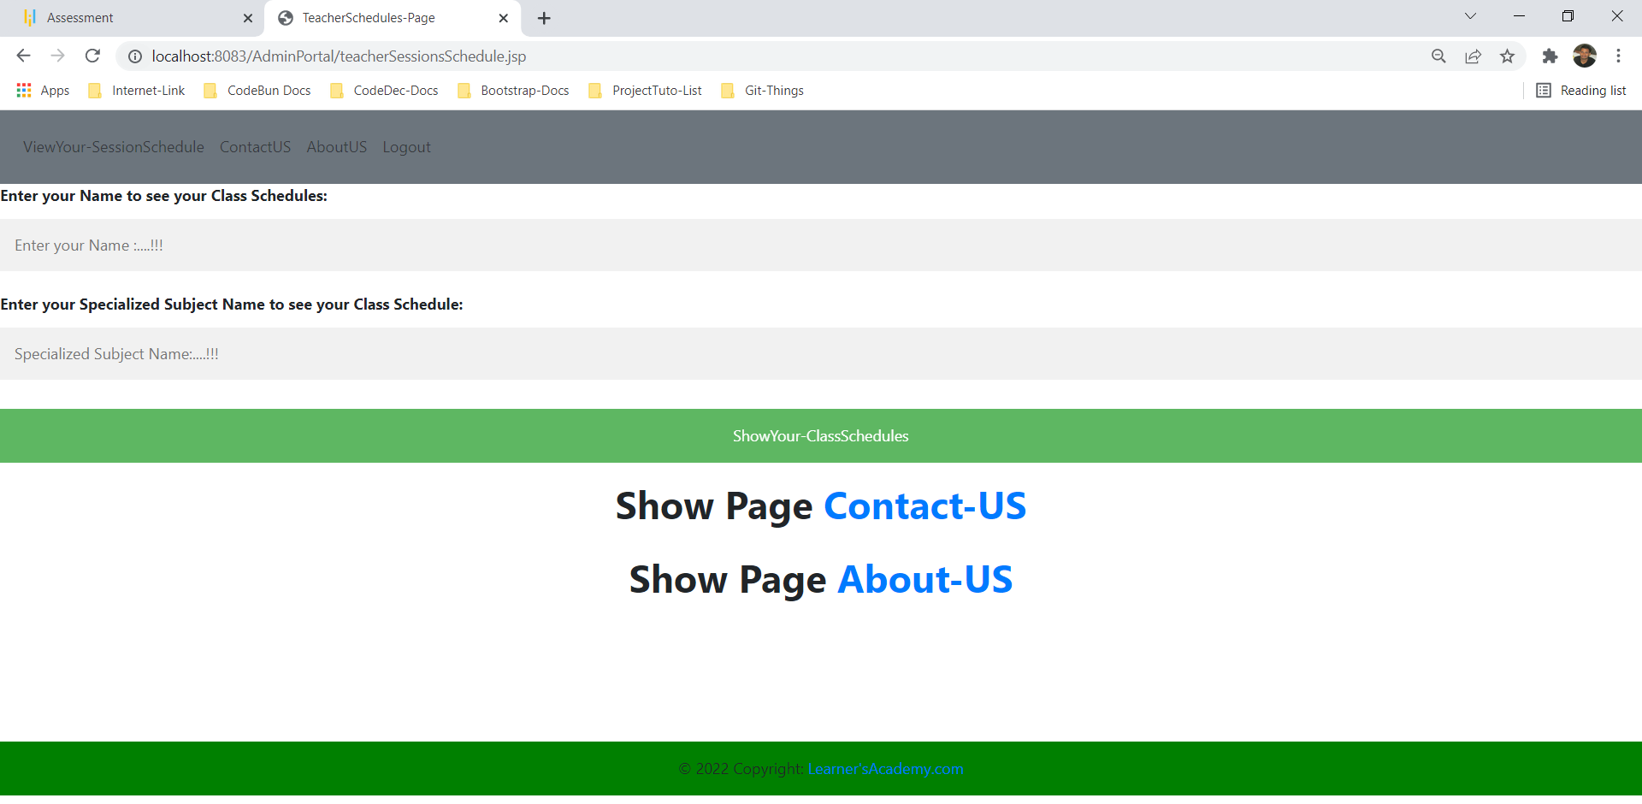

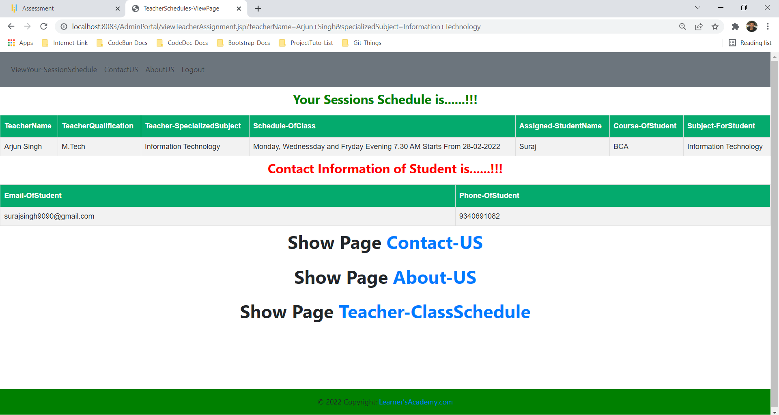

**Step 12-**

Forgot Password View Operation.

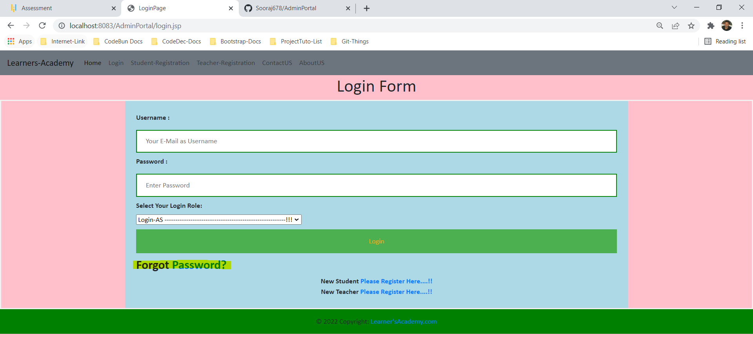

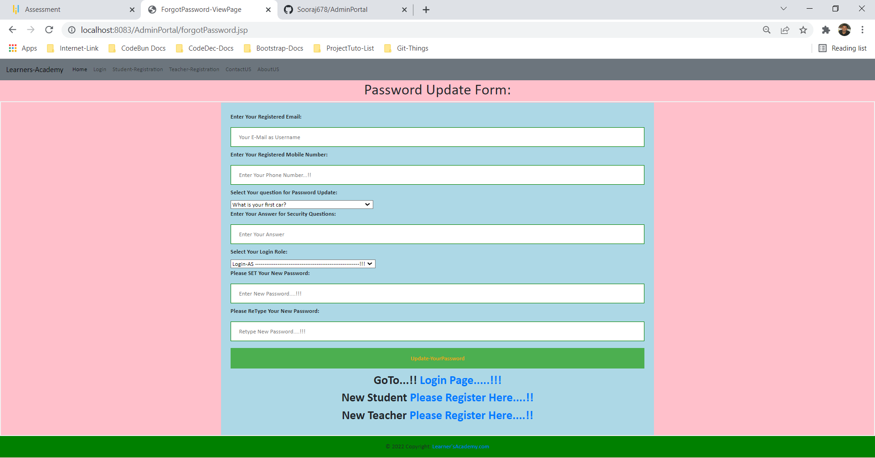

**Step 13-**

Contact-US View Operation for writing any query to us.

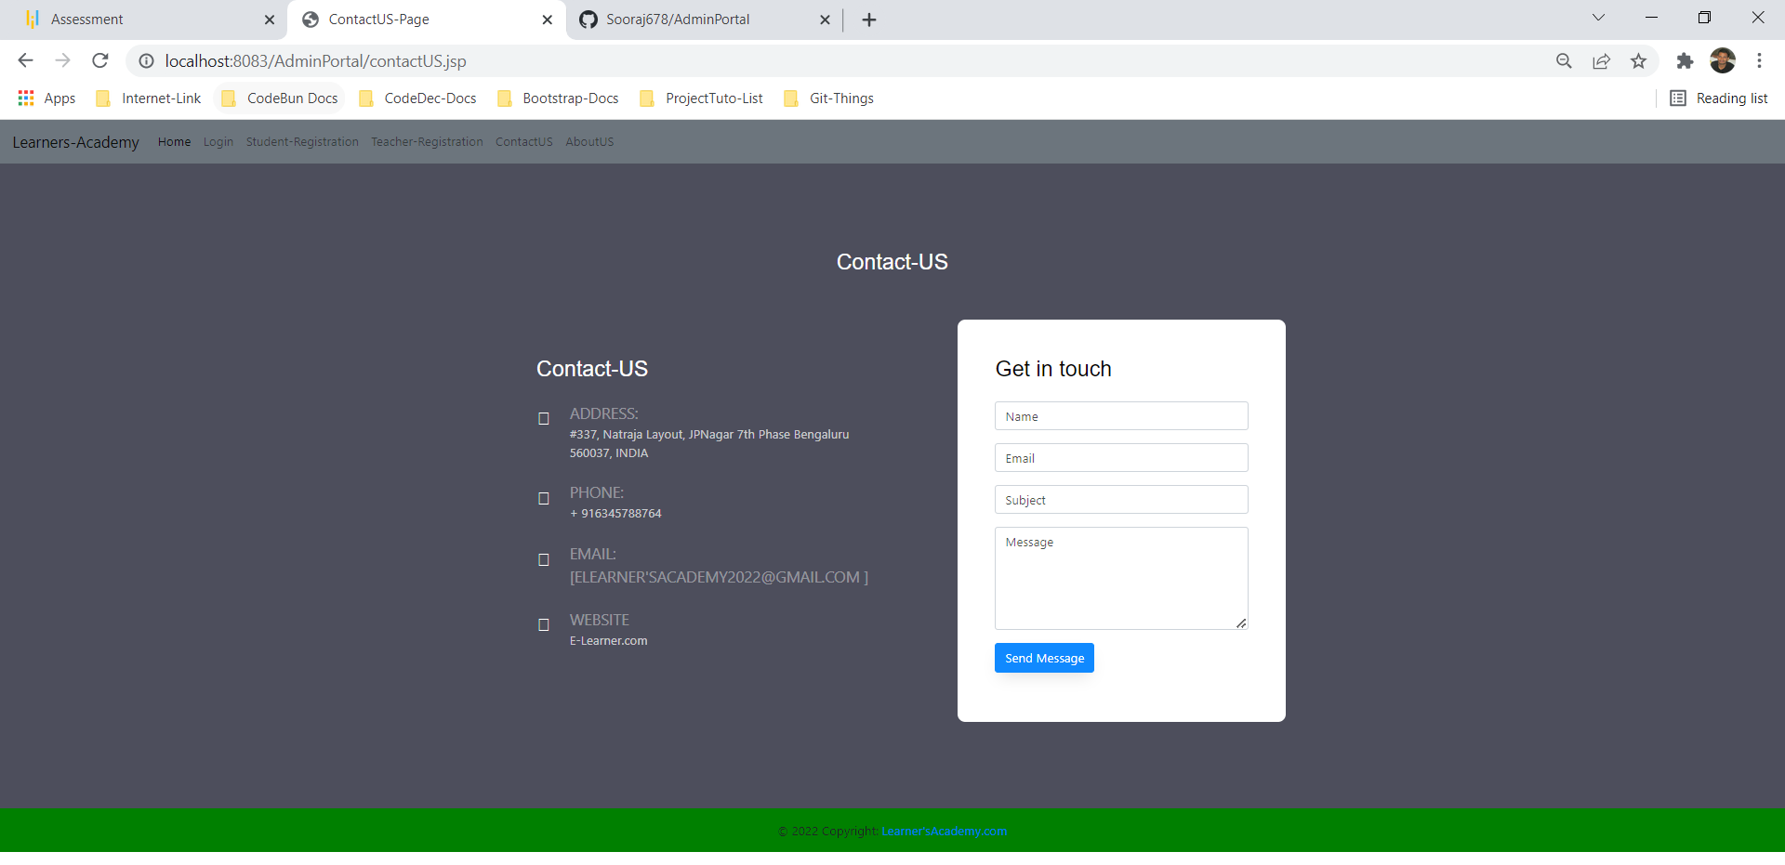

**Step 14-**

About-US View Operation for writing any query to us.

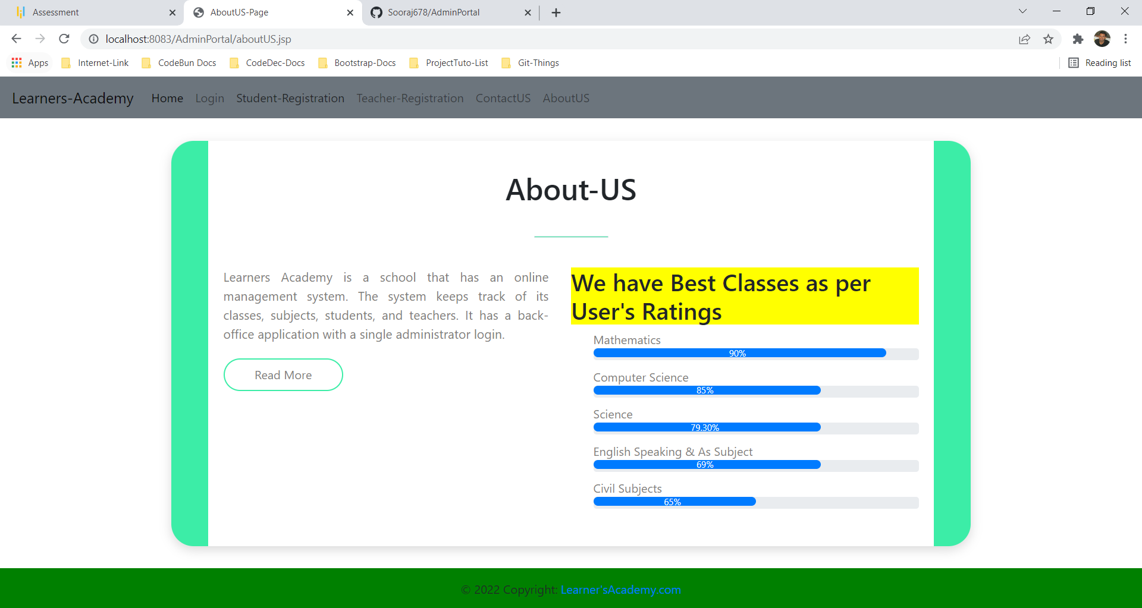

**Database: -**

In order to store the data of the students , classes, teachers, contactUS and usersadminportal there is a master datatbase called adminportal-phase2

There are 8 tables created to store the data.

1. AssignClass: - all the assigned classes details go here.
2. AssignTeacher: - contains all the assigned teachers’ data
3. AssignStudent: - contains all the data of students who has been assigned to at least a class.
4. Classes: - contains all the classes
5. Subjects: - contains all the subjects
6. Teachers: - contains all the teachers
7. ContactUS: - contains query information coming from users
8. Usersadminportal: - contains all registered user’s data.

**The Backend (DATABASE)**

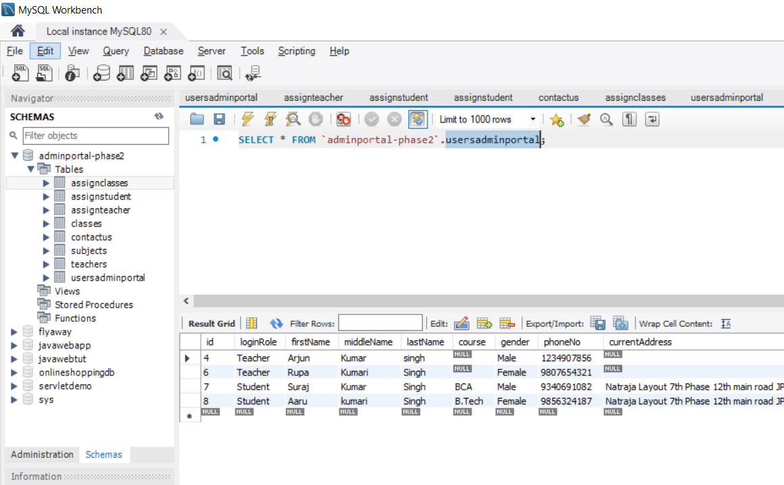

**Table 1: -**

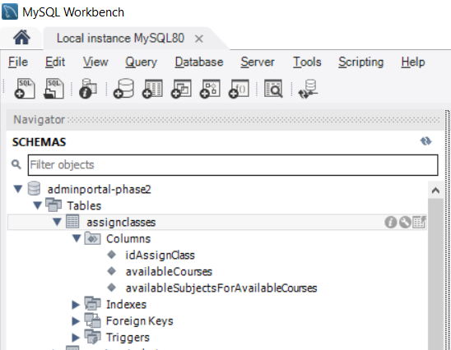

**Primary Key: - idAssignClass**

**Not Null: - not any column.**

**Table 2: -**

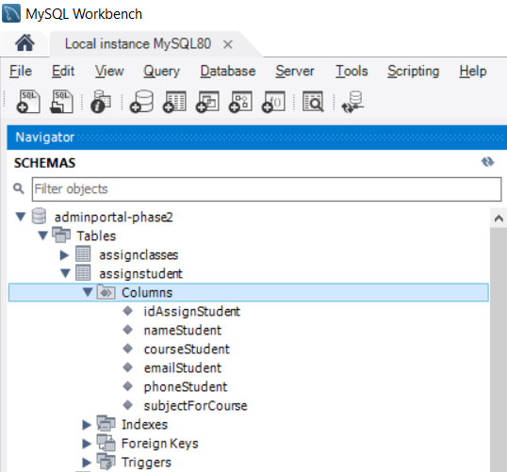

**Primary Key: - idAssignStudent**

**Not Null: - not any column.**

**Table 3: -**

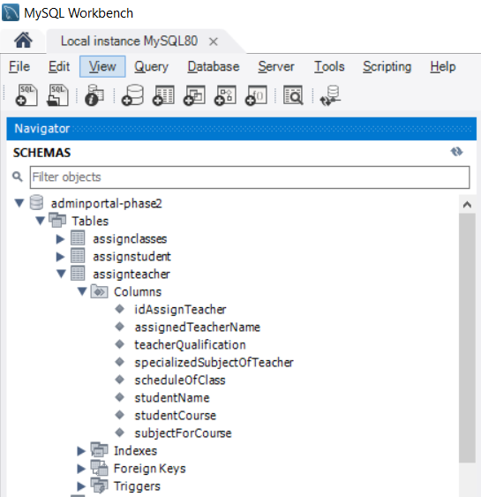

**Primary Key: - idAssignTeacher**

**Not Null: - not any column.**

**Table 4: -**

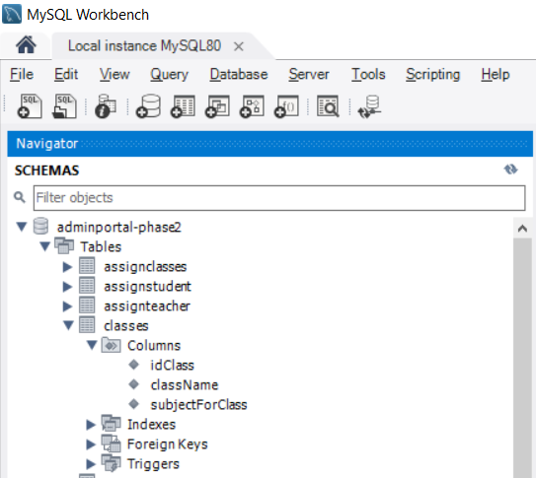

**Primary Key: - idClass**

**Not Null: - not any column.**

**Table 5: -**

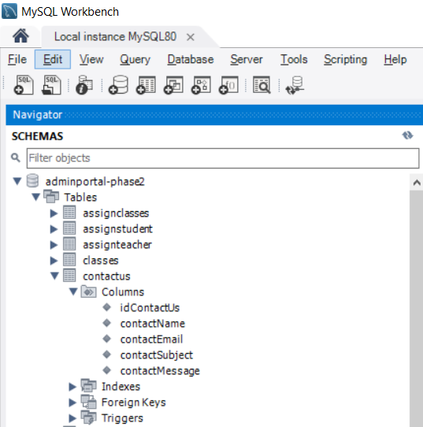

**Primary Key: - idContactUs**

**Not Null: - All remaining ones.**

**Table 6: -**

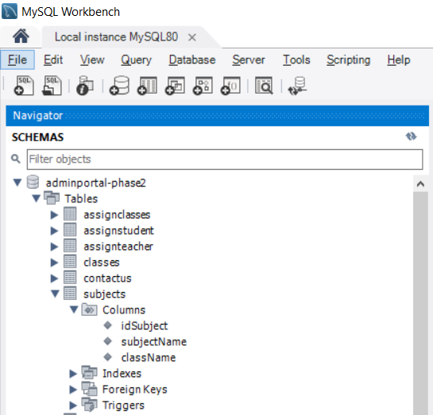

**Primary Key: - idSubject**

**Not Null: - not any column.**

**Table 7: -**

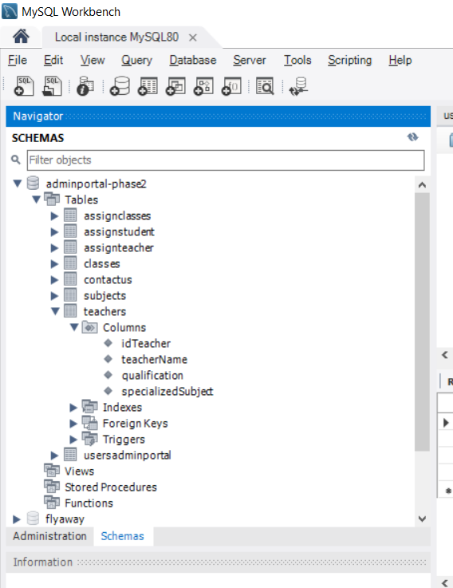

**Primary Key: - idTeacher**

**Not Null: - not any column.**

**Table 8: -**

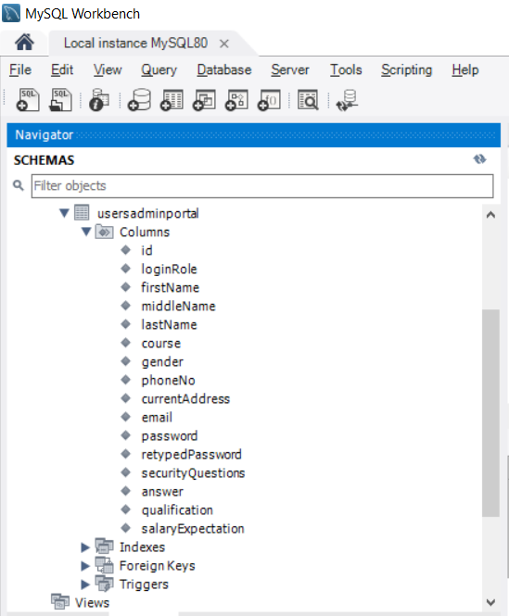

**Primary Key: - id**

**Not Null: - qualification, salaryExpectation and course can be null.**

**==========================================================**

**For accessing ADMIN Portal given Credentials must be:**

Username [-admin370@gmail.com](mailto:-admin370@gmail.com)

Password -admin123

Login AS -Admin

**6. GitHub link**

This section lists where the source code is located and from where the user can download and use it.

[**https://github.com/Sooraj678/AdminPortal**](https://github.com/Sooraj678/AdminPortal)